
- Jones:
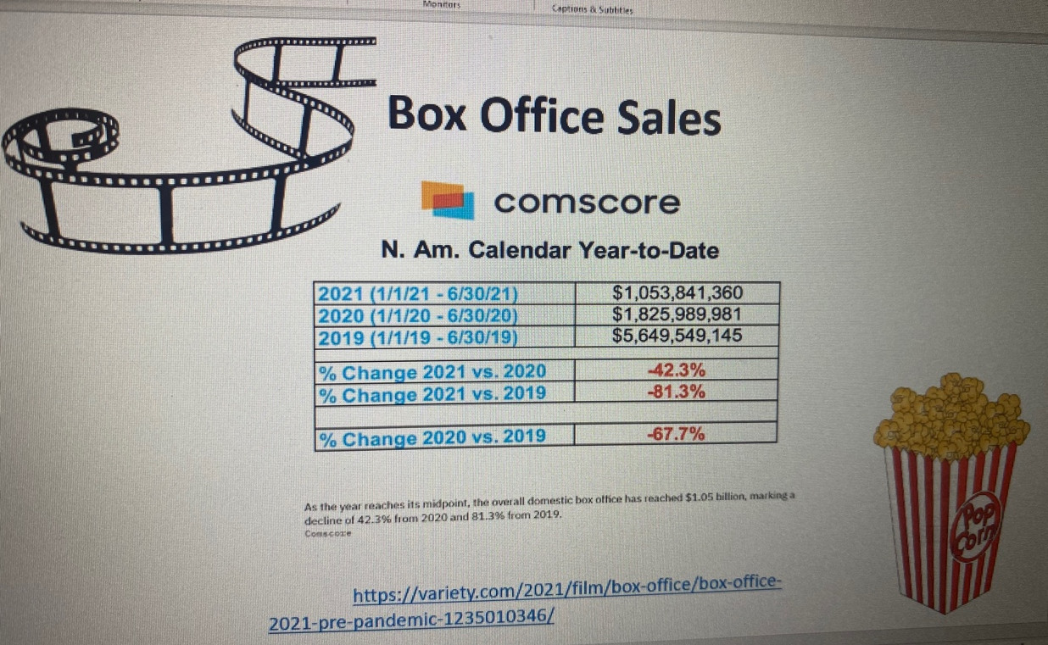
Visualization Slide:

Jones’s recording:

- Pepper:
Visualization Slide:
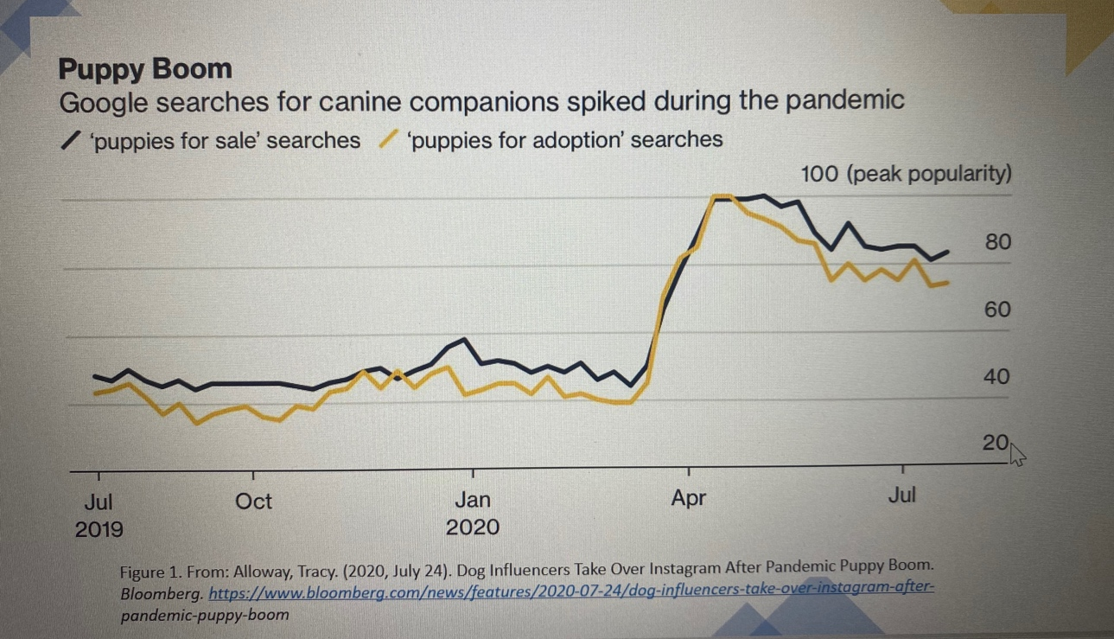

Pepper’s recording:

